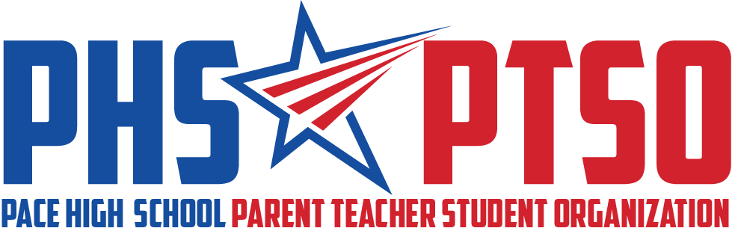

Meeting Minutes
Tuesday, October 11, 2022

I. Call to Order

The meeting was called to order at 8:05 am by President Roberta Panepinto.

II. Approval of Minutes

President Roberta Panepinto reviewed the September 13, 2022, Meeting Minutes. Tina Melder motioned for the minutes to be approved and it was seconded by Ken Parnell. The motion passed unanimously.

III. Reports from Board

President's Report
Roberta Panepinto welcomed everyone and thanked everyone for all the hard work and time spent on all the Homecoming week festivities. We have received good feedback and will use this feedback for planning the events in the future.

Shay Stallworth has joined the hospitality committee, and has already helped with several events. Anyone interested in joining the hospitality committee is welcome. We are still looking for people to join the communication committee.

Treasurer's Report
Tina Melder gave the Treasurer’s Report. The previous balance of the PTSO bank account was $18,132.71, ending balance of $19,531.42 as of October 11, 2022.

Homecoming festival was very successful. We sold drinks, candy and PTSO merchandise. Expenses were $409.71, and income was $1,211 for the event.

School Sponsor’s Report
Mrs. Cassevah wanted to thank us for all the help with decorating, etc for Homecoming. She would love to get feedback we have heard about the Homecoming dance, parade, festival, etc. Ended up selling a total 1,500 tickets to the dance, a lot of last minute sales.

IV. Old Business

Homecoming Parade/Festival (Community)
Lora and Tina are compiling all the feedback received in GroupMe. If anyone has additional feedback, feel free to text Tina or Lora. We already know that we need more petty cash (for change), less candy, more drinks to sell. Assess the trash situation, have it emptied several times during the festival. Food trucks were very successful and were happy with the event, asking to come back next year.

Teacher/Staff Lunch (Appreciation)
Lunch went great for all the teachers. We are at almost 100% teacher participation for membership.

Bus/Cust/Café Breakfast Bags (Appreciation)
We provided over 50 bus/café/custodians given breakfast or lunch. Chick-fil-A donated some sandwiches.

V. New and Ongoing Business

Membership Update (Community)
Two new family memberships, two new business memberships, and seven new staff memberships purchased in September. Only one or two staff members have not joined.

Food Pantry/Feeding the Gulf Coast (Community)
We have received a $5,000 grant from Feeding the Gulf Coast; they will be shipping a cabinet and supplies to the school. Two weeks of food will be delivered to the school on Thursday. We are funded for 25 students in need, and currently 12 students have received the backpacks. The PHS golf teams have donated toiletries, and we should have about 6 months worth. The next donations needed will be clothing to set up a clothing locker for the students.

Fundraising Update: Birthday Ads (Community)
Ads need to be in five days ahead of time. There is a possibility to get it on the sign last minute, but only if it is paid ahead of time and we can ask Mr. Goodwin.

Classroom Grants (Enhancements)
Expenses will be about $7,600 to fulfill all the grants. We can still use $1,500 in monetary donations from parents; we will extend the signup to October 31st.

Senior Lunch Cookies (Community)
November 15 we will provide cookies for the senior luncheon.

12 Days Update (Appreciation)
December 1st-16th will be 12 Days of Appreciation. Grinchmas is the theme. Staff lunch will be December 15th in the Media Center (beef tips catered by the Cutting Board). Mr. Shell is giving us $500 towards the lunch expense.

Advisor Feedback
PSAT is Wednesday and Thursday of this week.

Natalie is working on a “decisions day” to celebrate seniors – decisions for college, work, trade school, etc.

VI. Upcoming Events

Nov. 8th 8am: PTSO General Meeting
Nov 15th: Senior Luncheon (cookies)
Nov TBD: Veteran’s Day for military staff/spouses
Dec. 1st – Dec. 16th: 12 Days (Grinchmas)
Dec. 9th: Reading Café (Grinchmas)
Dec. 15th: Twelve Days staff lunch
No PTSO meeting in December

VII. Adjourn

The meeting was adjourned at 8:41 am. The following members were in attendance: Roberta Panepinto, Tina Melder, Erica Ortiz, Lisa Avila, Ken Parnell, Kandy McGinnis, Jennifer Smith, Victoria Mausteller, Amy O-Brian, Wyndi Wheaton, Claudia Cassevah, and Cassandra Hazelwood.

